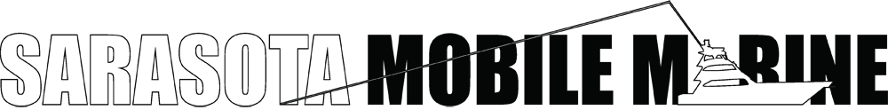

Chase Smith
941-350-8048
sarasotamm@gmail.com

‘98-’00 Palm Breeze Charters – www.airandsea.com
Boca Raton, FL.
Crew, Transport, Mechanic
Vessels:
- 35' Motion Race Cat powered by twin Mercury 525’s with top speeds of 110 mph
- 32' Power-play Super Vee-Twin powered by Mercury 525 Bulldogs with top speeds of 95mph
- 2 - 55' sailing cats powered by twin Yamaha four-stroke 225’s
Responsibilities:
- Vessel safety checks
- Detailing
- Engine services
- Vessel re-powers
- Crew for a variety of clientele including celebrities
- Transporting vessels through out country (in and out of water)
- Trailer maintenance

‘00-‘01 Turbine Marine - www.turbinemarine.com
Pompano Beach, FL.
Transport and Maintenance Mechanic

Responsibilities:
- Turbine/jet powered super boats including but not limited to: Mystic, Nor-tech, Platinum, Marine Technology Inc., and Skater boat hulls. Boats capable of speeds up too 220 mph
- Engine and drive installs and maintenance, complete rigging
- Extreme Race boat builds. everything from hatch installs, oxygen safety systems, Fireboy systems, gauges, engine mounts, and fuel systems.
- All Custom work

‘01-‘08 Supreme Marine Inc. – www.suprememarine.com
Ft. Lauderdale, FL.
Shop Foreman, Lead Mechanic, Transport

Vessels:
- 5 - 32' Doug Wright Super Stocks powered by 280 Mercury outboards with top speeds of 115mph
- 38' Fountain powered by Mercury 525’s with top speeds of 110mph
- 42' fountain powered by Mercury 525’s with top speeds of 115mph
- 42' fountain powered by Mercury 1400’s with top speeds of 160+mph

Responsibilities:
- Transporting across US
- Outboard maintenance and repowers.
- Complete rigging of both race boats and personal pleasure boats.
- Lead Mechanic of Crew of 8+ race teams
- Electronic installations including stereos, intercoms, radar, GPS, wiring harness, gauges, switch panels and trim systems.
- Drive rebuilds and service.
- Generator service and installs
- Bilge Systems
- Battery maintenance systems, battery switches, fuse panels and shore power systems
- Canvas and Upholstery
- Trailer service
- Bottom painting
- Fiberglass
- Complete engine maintenance
- 9 national championships
- 5 world championships

